**Dr Reddy’s Alumini Connect**

**Project Setup Document:**

First we have to install an IDE for development. I have used Visual Studio Code.

download the IDE: <https://code.visualstudio.com/download>

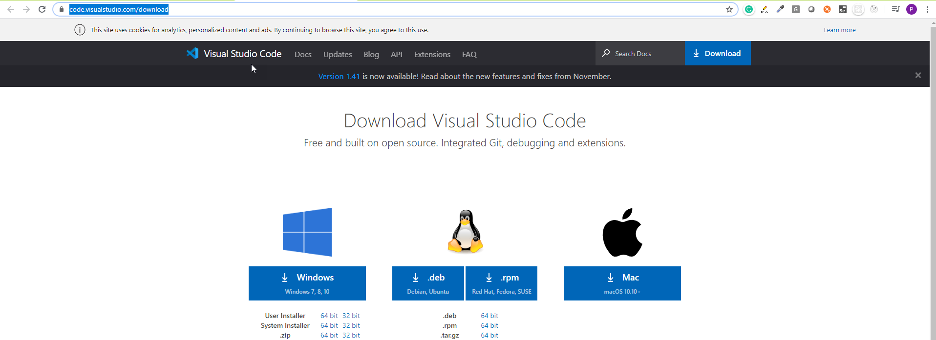

Clone the project *https://github.com/phanikumar-ffg/drrf-alumni-connect-web.git*

from GIT and import to IDE

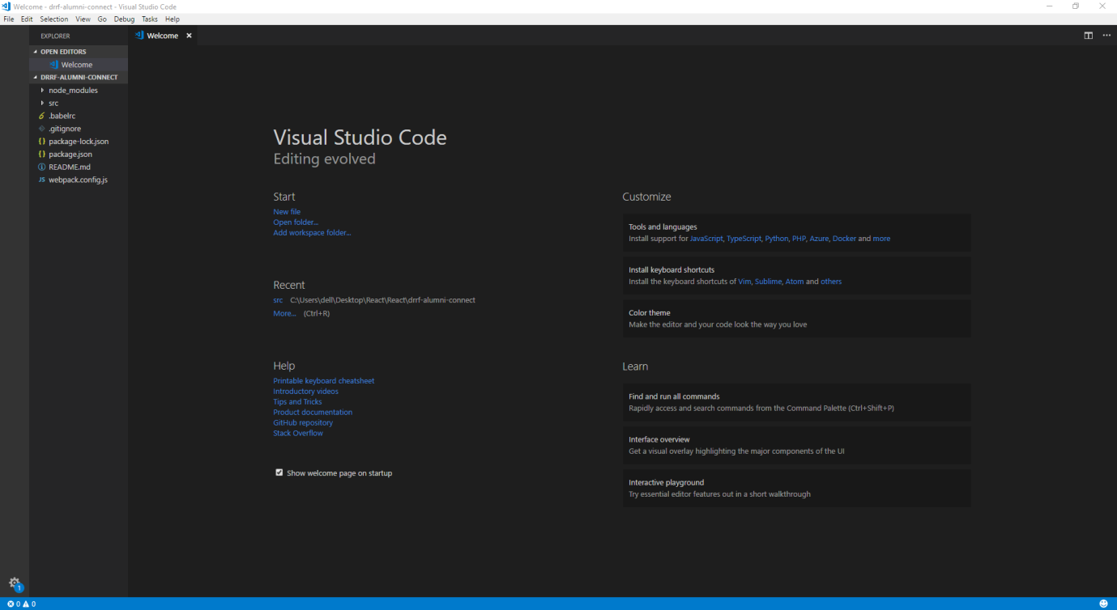

Open the Terminal to run the commands:

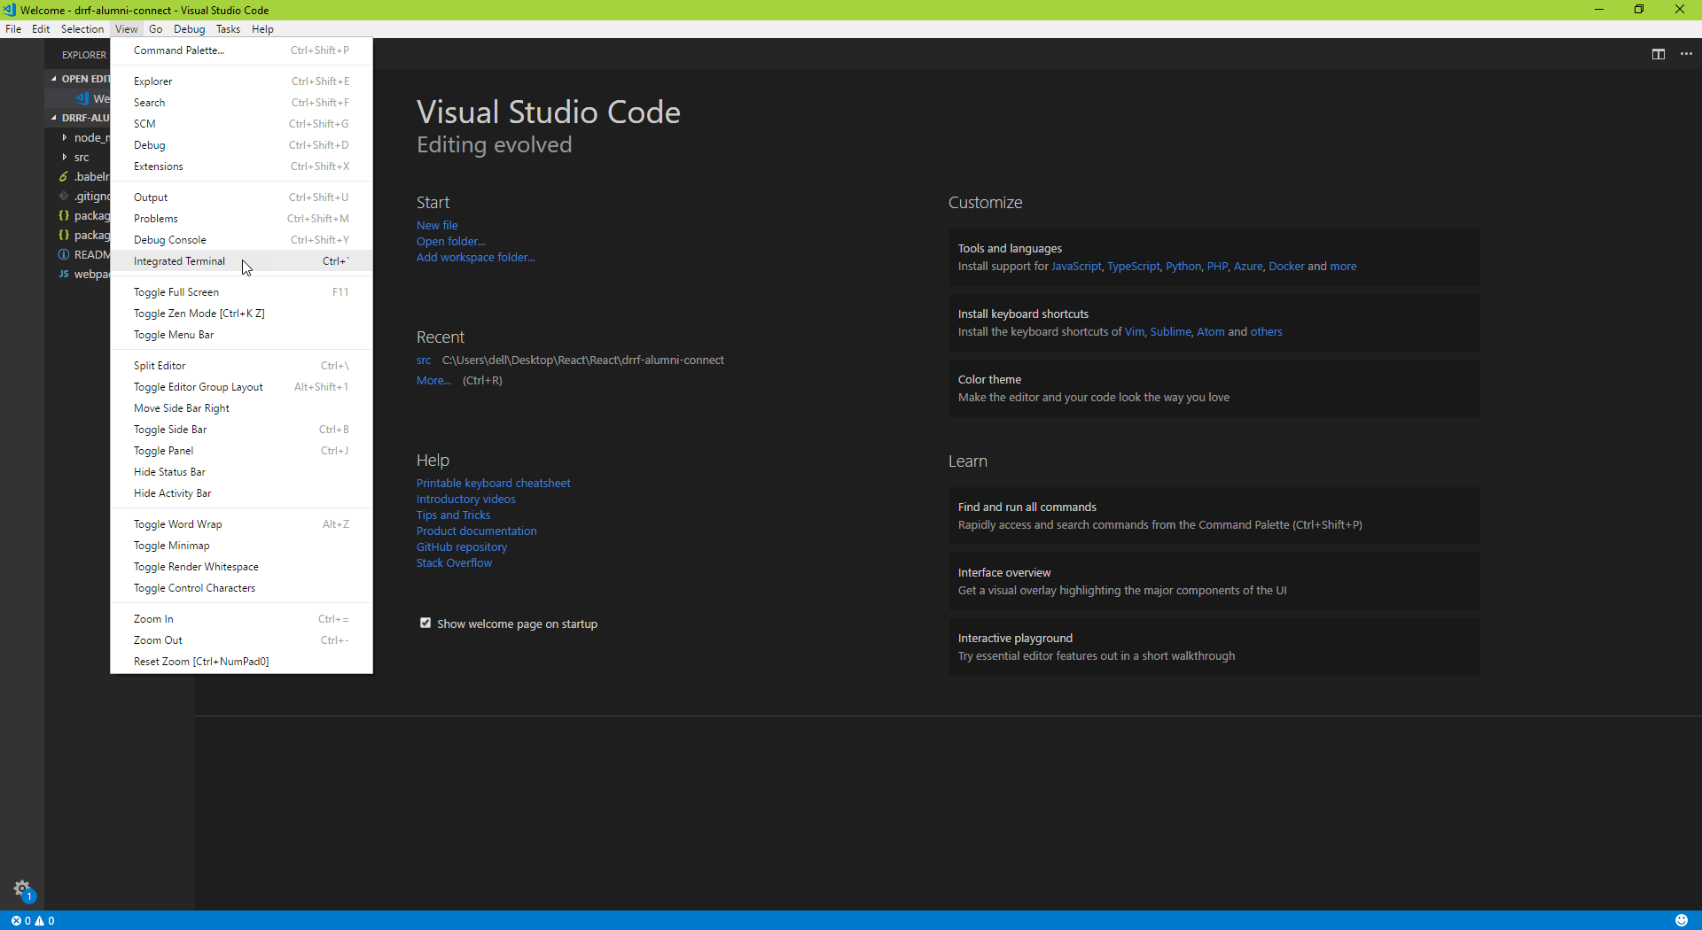

Run below command in terminal to install required files from npm repo

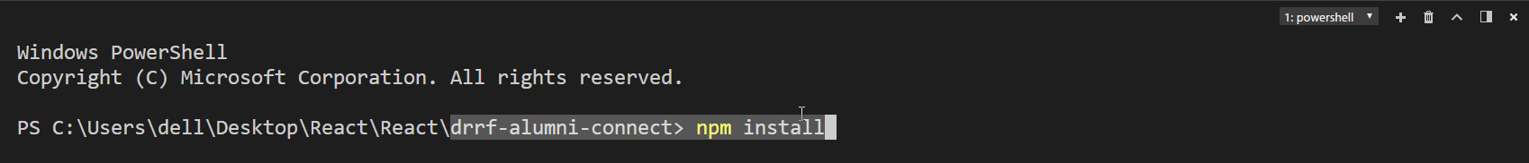

Run the below command to start the project:

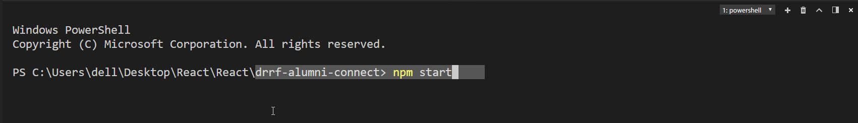

After running the above command successfully you can see the below screen.

